SOFTWARE REQUIREMENTS SPECIFICATION

**For**

**Recipe Management System**

**Prepared by:-**

***Arulselvan M***

***Priyadarshini S***

***Priyadharshini S***

# Introduction

## Purpose

The main objective of this document is to illustrate the requirements of the project Recipe Management system. The document gives the detailed description of the both functional and non-functional requirements proposed by the client. The purpose of this project is to provide a friendly environment to provide recipes for users. The main purpose of this project is to create, store and access recipes. This project describes the hardware and software interface requirements using ER diagrams and UML diagrams.

## Scope of Development Project

Recipe Management System is used to share the recipes of the culinary creators with ingredients list, approximate cost and Nutritional values of their recipes. So that users can easily know different recipes.

The project is specifically designed for the use of recipe creators and users. The product

will work as a complete user interface for recipe management process and recipe usage from ordinary users. Recipe Management System can be used by any existing or new recipe creator to manage their recipes by storing it. And for users, they can access, share, add the recipe to menu plan, add recipes to favorites.

The project can be easily implemented under various situations. We can add new features as and when we require, making reusability possible as there is flexibility in all the modules.

The language used for developing the project is Java as it is quite advantageous than other languages in terms of performance, tools available, cross platform compatibility, libraries, cost (freely available), and development process.

## Definitions, Acronyms and Abbreviations

JAVA -> platform independence SQL-> Structured query Language ER-> Entity Relationship

UML -> Unified Modeling Language

IDE-> Integrated Development Environment SRS-> Software Requirement Specification

## References

* + - Books

Software Engineering: A Practitioner’s Approach Fifth Edition By Roger S. Pressma

Software Requirements (Microsoft) Second Edition By Karl E. Wiegers

* + - Websites

https://www.systema.com/digital-transformation/recipe-management-systems

https://algotutor.io/javadbms/javadbmsprojecthackathon.pdf

# Overall Descriptions

## Product Perspective

Use Case Diagram of Recipe Management System

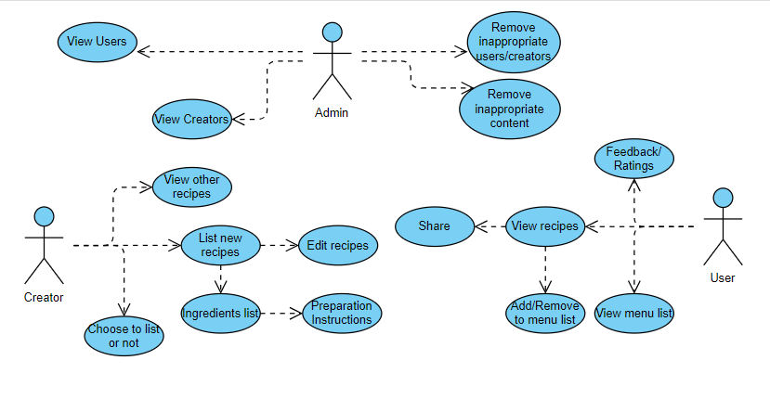

This is a broad level diagram of the project showing a basic overview. The users can be either recipe creator or user. This System will provide a search functionality to facilitate the search of recipes. This search will be based on various categories viz. Breakfast, Lunch, Dinner. Further the Recipe creator can add/update the recipes from the system. The users can access the recipes.

## Product Function

Entity Relationship Diagram of Recipe Management System

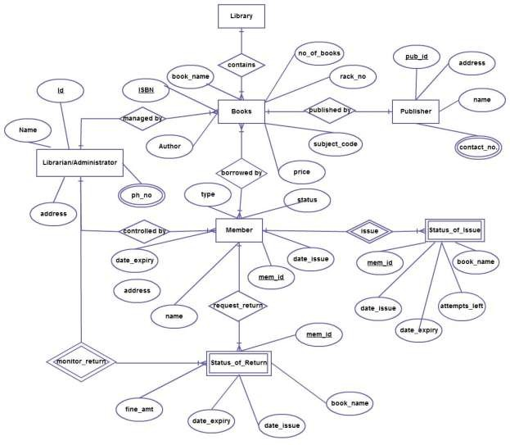

The Recipe Management System offers a real-time platform about the recipes available in the system. The main purpose of this project is to automate the process of managing recipes. This software is capable of facilitate recipe creation, user interactions, sharing recipes. The Admin will act as the system administrator to control users account and manage recipe. The system maintains the status of recipe creation, modifications and users feedback in the database. The user’s and the recipe creator’s details can be fetched by the admin from the database as and when required.

## User Classes and Characteristics

The system provides types of features based on the type of users [Admin/Creator/User].

The admin will be acting as the controller. The Creators can be chef or cook and Users can be anyone

who will be using the software.

The features of Admin are :-

* An Admin can view all the users profiles.
* An Admin can view all the creators’ profiles.
* Can remove the inappropriate content.
* Can remove the inappropriate users.

The features of Creators are :-

* Can list new recipes.
* Can edit recipes.
* Can list the necessary ingredients and preparation instructions for created recipes.
* Can choose to list or un-list the recipes created.
* Can view other creators’ recipes.

The features of Users are : -

* Can view recipes under each category.
* Can share recipes.
* Can add/remove recipes to menu list.
* Can add/remove recipes to favorites list.
* Can give feedback and ratings to recipes.
* Can view menu list.

## Operating Environment

The product will be operating in windows environment. The Recipe Management System is a Desktop Application.

The hardware configuration include Hard Disk: 40 GB, Monitor: 15” Color monitor, Keyboard: 122 keys. The basic input devices required are keyboard, mouse and output devices are monitor, printer etc.

## Assumptions and Dependencies

The assumptions are:-

* + - The coding should be error free
    - The system should be user-friendly so that it is easy to use for the users
    - The information of all users, creators and must be stored in a database that is accessible by the app
    - The system should have more storage capacity and provide fast access to the database
    - The system should provide search facility
    - The food recipe System is running 24 hours a day
    - Users must have their correct usernames and passwords to enter into their accounts and do actions

The dependencies are:-

* + - The specific hardware and software due to which the product will be run
    - Chefs and developers must carefully select and monitor the ingredients used to make dishes, verifying their form and functional profile.
    - Integrate with databases to retrieve nutritional information.
    - The end users (admin) should have proper understanding of the product.
    - The information of all the users must be stored in a database that is accessible by the food recipe management system.
    - Any update regarding the recipe from the creators is to be recorded to the database.

## Requirement

Software Configuration:-

This software package is developed using java as front end which is supported by sun micro system. Microsoft SQL Server as the back end to store the database.

Operating System: Windows NT, windows 98, Windows XP Language: Java Runtime Environment, Eclipse 4.29

Database: MS SQL Server (back end)

Hardware Configuration:-

Processor: Quad-core Intel-Xeon

Hard Disk: 40GB

RAM: 16 GB or more

## Data Requirement

The inputs consist of the query to the database and the output consists of the solutions for the query. The output also includes the user receiving the details of their accounts. In this project the inputs will be user details or recipe given by users or creators which is queried in the background and stored in the database.

# External Interface Requirement

## GUI

The software provides good graphical interface for the user, creator and the admin can operate on the system, performing the required task such as create, store, edit, viewing the details of the recipes.

* + - It allows user to view and access the recipes quickly.
    - It provides different categories and search facility for the users.
    - All the modules provided with the software must fit into this graphical user interface and accomplish to the standard defined
    - The design should be simple and all the different interfaces should follow a standard template.
    - The user interface should be able to interact with the user management module and a part of the interface must be dedicated to the login/logout module

Login Interface:-

In case the user is not yet registered, he can enter the details and register a new account. Once his account is registered he can ‘Login’ which asks the user to type his email and password. If the user entered wrong email or password then an error message pop-ups.

Search:-

The user or creator can use the search option to search the recipe he is looking for, by entering the recipe/dish name.

Categories View:-

In categories view the recipes are displayed based on certain categories(i.e. breakfast, lunch, dinner).

Admin’s Control Panel:-

This control panel will allow admin to view all the users and creators. And admin has the only access to edit the users and creators table. He can remove any inappropriate content or inappropriate users or creators from the system.

User:-

The users are provided with the option to add recipes to the menu list. Share the recipe to others and can give feedback/ratings after using a recipe.

Creator’s Panel:-

The creators are provided with the option to create a new recipe or edit the existing recipe or delete the recipe, he is also provided with the option to list his recipes or not.

Menu List:-

In the menu list the users can add/remove the recipes they liked based on the categories.

# System Features

The users of the system should be provided the surety that their account is secure. This is possible by providing:-

* Each member will be assigned a unique Member ID, which will serve as a primary identifier for validation purposes.
* Removing inappropriate posts and users from database.
* Proper accountability which includes not allowing a member to see other member’s account. Only admin will see and manage all member accounts.
* Menu list to store the menu plan based on the categories.
* Favorites section to save favorites which can be useful in the future.
* Edit options for recipe can be helpful for creator to make changes based upon user feedback.

# Other Non-functional Requirements

## Performance Requirement

The proposed system will provide the users with different recipes along with its ingredients list, Approximate cost and Nutritional value.

* + - The performance of the system should be fast and accurate.
    - Recipe Management System shall handle expected and non-expected errors in ways that prevent loss in information. Thus it should have inbuilt error testing to identify invalid email/password.
    - The system should be able to handle large amount of data. Thus it should accommodate high number of recipes and users without any fault.

## Safety Requirement

The database may get crashed at any certain time due to virus or operating system failure. Therefore, it is required to take the database backup so that the database is not lost.

## Security Requirement

* + - System will use secured database
    - Normal users can just read information but they cannot edit or modify anything except their personal data and some other information.
    - System will have different types of users and every user has access constraints
    - No one should be able to hack users’ password.
    - There should be separate accounts for admin and members such that no member can

update the user or creator information and only the admin has the rights to update the database.

## Requirement attributes

* + - Collect user requirements for recipe creation and sharing.
    - Understand the importance of ingredient details and user ratings.
    - Define access control and sharing options.

## User Requirement

The users of the system are users, creators and a admin who maintains the system. The users are assumed to have basic knowledge of the computers and internet browsing. The admin of the system should have more knowledge of the internals of the system and is able to rectify the small problems that may arise due to disk crashes, power failures and other catastrophes to maintain the system. The proper user interface, user manual, online help and the guide to install and maintain the system must be sufficient to educate the users on how to use the system without any problems.

The admin provides certain facilities to the users in the form of:-

* + - Backup and Recovery
    - Forgot Password
    - Data migration i.e. whenever user registers for the first time then the data is stored in the server
    - Data replication i.e. if the data is lost in one branch, it is still stored with the server
    - Auto Recovery i.e. frequently auto saving the information
    - The server must be maintained regularly and it has to be updated from time to time

# Other Requirements

## Data and Category Requirement

There are different categories of users namely Users, Admin, Creators. Depending upon the category of user the access rights are decided. It means if the user is an administrator then he can be able to modify the data, delete, append etc. All other users except the admin only have the rights to retrieve the information about database. Similarly there will be different categories of recipes available. According to the categories of recipes their relevant data should be displayed. The categories and the data related to each category should be coded in the particular format.

## Glossary

The following are the list of conventions and acronyms used in this document and the project as well:

* + - Administrator: A login id representing a user with user administration privileges to the software
    - User: A general login id assigned to most users
    - Client: Intended users for the software
    - SQL: Structured Query Language; used to retrieve information from a database
    - SQL Server: A server used to store data in an organized format
    - Layer: Represents a section of the project
    - User Interface Layer: The section of the assignment referring to what the user interacts with directly
    - Application Logic Layer: The section of the assignment referring to the Web Server. This is where all computations are completed
    - Data Storage Layer: The section of the assignment referring to where all data is recorded
    - Use Case: A broad level diagram of the project showing a basic overview
    - Class diagram: It is a type of static structure diagram that describes the structure of a system by showing the system’s cases, their attributes, and the relationships between the classes
    - Interface: Something used to communicate across different mediums
    - Unique Key: Used to differentiate entries in a database

## Class Diagram

A class is an abstract, user-defined description of a type of data. It identifies the attributes of the data and the operations that can be performed on instances (i.e. objects) of the data. A class of data has a name, a set of attributes that describes its characteristics, and a set of operations that can be performed on the objects of that class. The classes’ structure and their relationships to each other frozen in time represent the static model. In this project there are certain main classes which are related to other classes required for their working. There are different kinds of relationships between the classes as shown in the diagram like normal association, aggregation, and generalization. The relationships are depicted using a role name and multiplicities. Here ‘Librarian’, ‘Member’ and ‘Books’ are the most important classes which are related to other classes.

